Project Model Labs

~ Developed by Joy Patel & Darshi Adroja

Project ModelLabs is an intelligent Model Discovery and Optimization Platform designed to simplify the process of selecting and developing machine learning models. Choosing the most suitable model for a dataset often requires extensive experimentation with multiple algorithms, preprocessing techniques, feature engineering methods, and hyperparameter configurations. This iterative process is both time-consuming and computationally expensive, particularly for students, machine learning beginners, and organizations with limited expertise.
Project ModelLabs addresses this challenge by automating the end-to-end model discovery workflow. Users simply upload a dataset, after which the platform automatically analyses the data, identifies the underlying machine learning task, performs the necessary preprocessing, and benchmarks multiple suitable machine learning algorithms. Rather than relying on generic assumptions about which algorithm is likely to perform best, the platform evaluates candidate models on the provided dataset and ranks them according to their performance.
When deep learning is identified as a promising solution, Project ModelLabs further enhances the search process through Neural Architecture Search (NAS), enabling automatic exploration and optimization of neural network architectures. The final recommendation is based entirely on empirical evaluation, ensuring that the selected model is supported by measurable performance rather than predefined heuristics.
Beyond model selection, the platform generates comprehensive evaluation reports including performance metrics, confusion matrices, ROC curves, feature importance analysis, and detailed explanations of the model selection process. Users can also download the trained model for deployment or further experimentation.
The primary objective of Project ModelLabs is to provide an evidence-driven machine learning platform that enables users to efficiently discover, compare, optimize, and deploy high-performing models through an intuitive and automated workflow.

Introduction
This document presents the Software Requirements and System Design Specification (SRSD) for Project ModelLabs, an intelligent Model Discovery and Optimization Platform. It serves as the primary technical blueprint for the project by documenting the overall vision, requirements, architectural design, development approach, and planned implementation of the system.
The primary purpose of this document is to establish a clear understanding of the project's objectives before implementation begins. By defining the system requirements, architecture, and development roadmap in advance, it provides a structured foundation that simplifies implementation, improves decision-making, and reduces ambiguity throughout the software development lifecycle.
This document is intended primarily for the project developer and future contributors who may extend, maintain, or enhance Project ModelLabs. It also serves as a technical reference for project supervisors, evaluators, and other stakeholders who wish to understand the motivation, design decisions, and engineering approach adopted during development.
Upon completion of this document, readers should have a comprehensive understanding of the motivation behind Project ModelLabs, the problems it aims to solve, the proposed solution, the overall system architecture, the major functional and non-functional requirements, and the planned development strategy.
The scope of this document includes the project's requirements, high-level system architecture, machine learning workflow, module design, technology selection, development timeline, and future roadmap. It is intended to guide the design and implementation of the platform rather than describe the implementation itself.
This document intentionally excludes implementation-specific details such as source code, deployment procedures, installation instructions, and user operation manuals. These aspects will be documented separately as the project progresses.

Functional Requirements
The functional requirements define the core capabilities that Project ModelLabs must provide to automate the machine learning workflow. These requirements describe the expected behaviour of the system, from dataset ingestion to model recommendation and result generation.
1 Dataset Management
FR-001: The system shall allow users to upload datasets in CSV and Microsoft Excel (XLS/XLSX) formats.
FR-002: The system shall validate uploaded datasets by checking for empty files, unsupported formats, duplicate columns, missing or invalid values, inconsistent data types, excessive file size, and other structural inconsistencies before processing.
FR-003: The system shall generate a dataset overview that includes dataset dimensions, feature names, data types, missing value statistics, descriptive statistics, and a preview of the uploaded data.
2 Problem Identification
FR-004: The system shall automatically identify the type of machine learning problem, such as classification or regression, based on the characteristics of the uploaded dataset.
FR-005: The system shall allow users to manually specify the target variable. If no target variable is provided, the system shall automatically identify the most suitable target column using predefined heuristics.
3 Data Preparation
FR-006: The system shall automatically preprocess the dataset before model training by performing tasks such as handling missing values, encoding categorical features, scaling numerical features, managing outliers where applicable, and selecting relevant features when beneficial.
4 Model Discovery and Evaluation
FR-007: The system shall identify and train all suitable machine learning models based on the detected problem type and dataset characteristics.
FR-008: The system shall allow users to select the optimization objective, including maximizing predictive performance, minimizing inference time, or reducing model complexity, before model training begins.
FR-009: The system shall evaluate each trained model using appropriate performance metrics and rank all models on a leaderboard according to the selected optimization objective.
5 Neural Architecture Search (NAS)
FR-010: The system shall initiate Neural Architecture Search only when deep learning models demonstrate competitive performance compared with classical machine learning models.
FR-011: The Neural Architecture Search module shall optimize predefined neural network architecture and training hyperparameters, including the number of hidden layers, number of neurons, activation functions, dropout rate, optimizer, learning rate, and batch size.
6 Results and Reporting
FR-012: The system shall present a comprehensive results dashboard displaying the ranked model leaderboard, performance metrics, evaluation visualizations, and model-specific insights.
FR-013: The system shall allow users to download the best-performing trained model for future inference and deployment.
FR-014: The system shall automatically generate a downloadable PDF report summarizing the dataset characteristics, preprocessing steps, evaluated models, performance comparison, selected model, and key findings from the experiment.

Non-Functional Requirements
The non-functional requirements define the quality attributes and operational characteristics of Project ModelLabs. These requirements ensure that the platform remains efficient, reliable, secure, maintainable, and scalable while providing a consistent user experience.
1 Performance
NFR-001: The system shall provide responsive dataset validation and profiling while maintaining high processing efficiency.
NFR-002: The system shall optimize resource utilization during model training to achieve the best possible performance without compromising prediction accuracy.
NFR-003: Long-running machine learning tasks shall execute asynchronously, allowing users to monitor progress without blocking the application interface.
2 Scalability
NFR-004: The system shall support multiple concurrent users without significant degradation in performance.
NFR-005: The architecture shall be designed to support future horizontal scaling and cloud-based deployment.
3 Reliability
NFR-006: If training of an individual machine learning model fails, the system shall continue training the remaining eligible models and log the failure for later review.
NFR-007: The system shall preserve experiment progress and user history whenever possible to minimize data loss caused by unexpected interruptions.
4 Security
NFR-008: The system shall provide authenticated user accounts to ensure that each user's datasets, experiments, trained models, and reports remain private.
NFR-009: User data shall be isolated so that no user can access another user's experiments or uploaded datasets.
NFR-010: The system shall securely store user information and experiment metadata using appropriate security practices.
5 Usability
NFR-011: The platform shall provide a dashboard-based user interface with an intuitive and user-friendly workflow.
NFR-012: The interface shall present experiment progress, model rankings, and results in a clear and easily understandable manner.
6 Maintainability
NFR-013: The system shall follow a modular architecture that separates the frontend, backend, machine learning engine, and database components.
NFR-014: The architecture shall support the addition of new preprocessing techniques, machine learning algorithms, evaluation metrics, and optimization strategies with minimal changes to existing modules.
7 Portability
NFR-015: Version 1 of the platform shall support deployment on Windows-based systems.
NFR-016: The system architecture shall be designed to facilitate future deployment on cloud platforms without major architectural modifications.
8 Compatibility
NFR-017: The web application shall be fully compatible with the latest version of Google Chrome.
NFR-018: The system shall expose standard RESTful APIs to enable future integration with external services and applications.

System Architecture
The system architecture of Project ModelLabs is designed using a modular and service-oriented approach to ensure scalability, maintainability, and extensibility. Each major component of the platform is responsible for a specific set of tasks, allowing independent development, testing, and future enhancements without affecting the overall system.
The architecture follows a layered design consisting of a presentation layer, application layer, machine learning layer, and data layer. User requests originate from the web interface, are processed by backend services, and are forwarded to the machine learning engine for data processing, model training, evaluation, and recommendation. The generated results, trained models, reports, and experiment history are then stored and presented back to the user through an interactive dashboard.

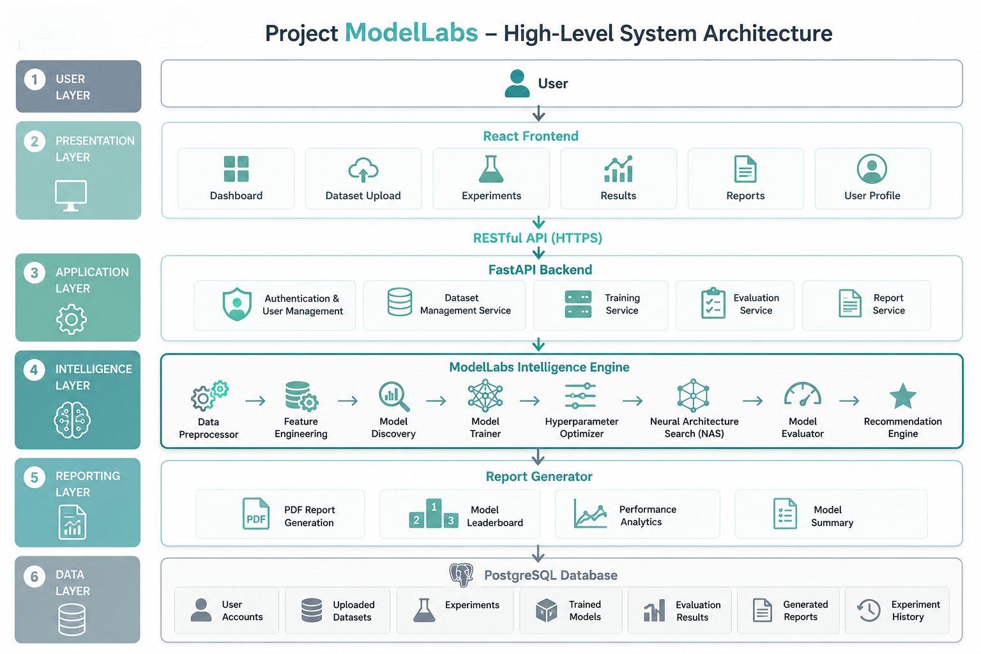

Technology Selection and Justification
The implementation of Project ModelLabs requires a robust and scalable technology stack capable of supporting modern web development, machine learning workflows, Neural Architecture Search (NAS), and efficient data management. Each technology has been selected after evaluating multiple alternatives based on factors such as performance, scalability, maintainability, community support, ease of integration, and long-term sustainability.
The following table summarizes the technologies selected for the project along with the alternatives considered and the rationale behind each decision.
Component | Alternatives Considered | Selected Technology | Justification
Frontend Framework | Angular, Vue.js | React.js | React provides a component-based architecture, excellent performance through its virtual DOM, a large ecosystem, and seamless integration with REST APIs.
UI Styling | Bootstrap, Material UI | Tailwind CSS | Tailwind CSS enables rapid UI development through utility-first styling while providing complete design flexibility and responsive layouts.
Backend Framework | Flask, Django | FastAPI | FastAPI offers high-performance asynchronous request handling, automatic API documentation, type validation, and excellent compatibility with machine learning applications.
Authentication | Session Authentication, OAuth Only | JWT Authentication | JWT provides secure, stateless authentication suitable for RESTful APIs while enabling scalable user session management.
Database Management System | MySQL, MongoDB | PostgreSQL | PostgreSQL offers strong ACID compliance, excellent relational data management, high reliability, and efficient handling of structured experiment data.
Object Relational Mapper (ORM) | Peewee, Django ORM | SQLAlchemy | SQLAlchemy provides flexible database abstraction, simplifies CRUD operations, and integrates seamlessly with FastAPI and PostgreSQL.
Classical Machine Learning | Weka, ML.NET | Scikit-learn | Scikit-learn provides a comprehensive collection of reliable machine learning algorithms with a consistent API and extensive community support.
Deep Learning Framework | TensorFlow, Keras | PyTorch | PyTorch offers dynamic computation graphs, greater flexibility for experimentation, and strong support for implementing Neural Architecture Search algorithms.
Hyperparameter Optimization | Hyperopt, Ray Tune | Optuna | Optuna provides efficient optimization algorithms, pruning capabilities, and easy integration with both Scikit-learn and PyTorch models.
Data Processing | Polars, Dask | Pandas & NumPy | Pandas and NumPy are industry-standard libraries that provide efficient data preprocessing, feature engineering, numerical computation, and data manipulation.
Data Visualization | Seaborn, Bokeh | Matplotlib & Plotly | Matplotlib produces publication-quality visualizations, while Plotly enables interactive charts for dashboards and experiment analysis.
Report Generation | FPDF, WeasyPrint | ReportLab | ReportLab supports structured PDF generation with precise formatting, making it suitable for automated experiment reports.
Version Control | GitLab, Bitbucket | Git & GitHub | Git and GitHub provide reliable version control, collaborative development, issue tracking, and repository management following industry standards.
Development Environment | PyCharm, IntelliJ IDEA | Visual Studio Code | Visual Studio Code offers lightweight performance, extensive extension support, integrated debugging, and compatibility with the entire technology stack used in Project ModelLabs.

Technology Selection Strategy
The technology stack for Project ModelLabs was selected after evaluating multiple alternatives against the functional and non-functional requirements of the platform. The primary selection criteria included performance, scalability, ease of integration, maintainability, community adoption, documentation quality, and long-term sustainability.
Preference was given to technologies that are widely adopted in modern software engineering and machine learning workflows while maintaining compatibility across all system components. This approach ensures that the platform remains modular, extensible, and capable of supporting future enhancements such as additional machine learning algorithms, cloud deployment, distributed training, and advanced Neural Architecture Search techniques without requiring significant architectural modifications.
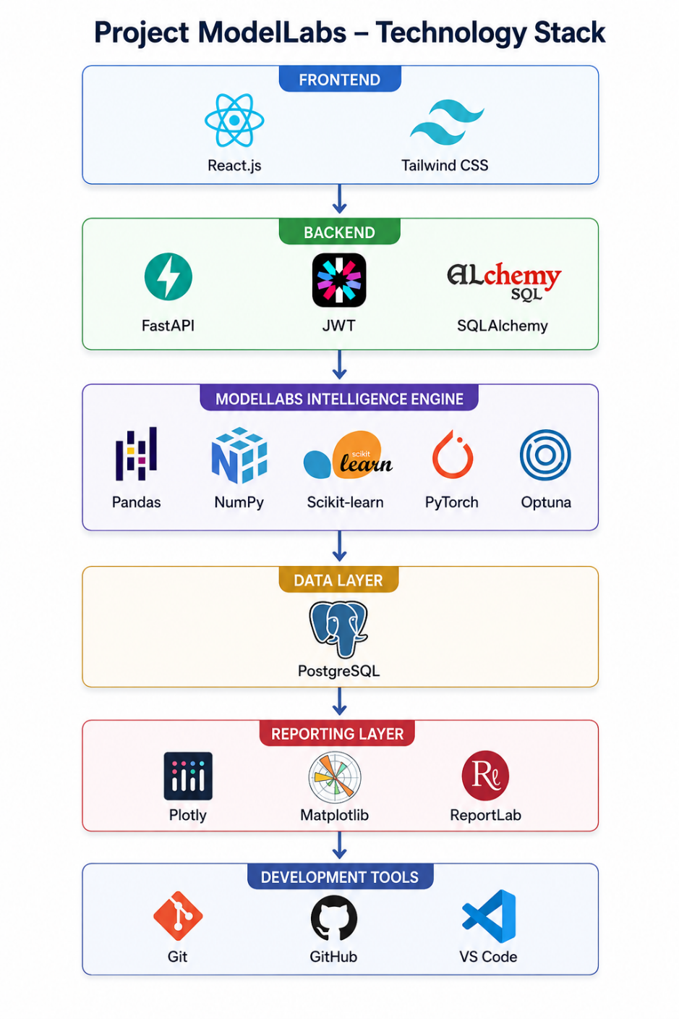

System Workflow
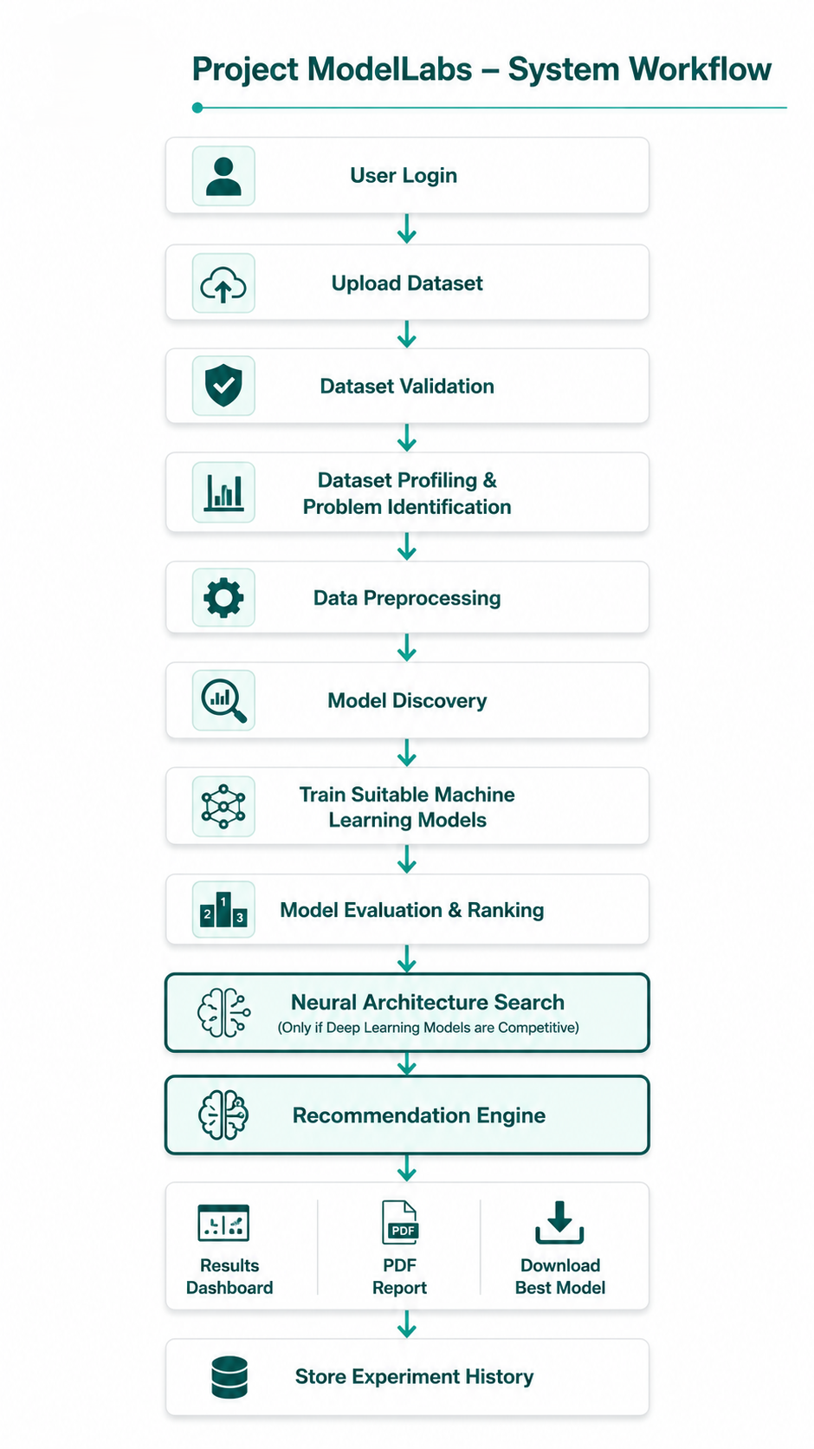

Development Timeline
The development of Project ModelLabs is planned over a four-week period following an incremental approach. Each week focuses on a major milestone, ensuring systematic progress from system design to final deployment while allowing adequate time for integration and testing.
Week 1 – Planning and System Design
The first week focuses on requirement analysis, project planning, and designing the overall system architecture. During this phase, the functional and non-functional requirements are finalized, the database schema and API structure are designed, and the user interface layouts are planned. This phase establishes the foundation for the entire project.
Week 2 – Application Development
The second week is dedicated to developing the core web application. The React frontend, FastAPI backend, authentication system, dataset management module, and database integration are implemented. Communication between the frontend and backend is established through RESTful APIs, resulting in a functional application capable of managing users and datasets.
Week 3 – ModelLabs Intelligence Engine
The third week focuses on implementing the intelligent machine learning pipeline. Data preprocessing, feature engineering, automatic problem identification, model discovery, classical machine learning algorithms, model evaluation, and the recommendation engine are developed. Neural Architecture Search (NAS) and hyperparameter optimization are then integrated to automatically discover optimized deep learning architectures when appropriate.
Week 4 – Testing, Optimization, and Deployment
The final week is dedicated to system integration, functional testing, performance evaluation, bug fixing, and optimization. Automated report generation and experiment history management are completed, followed by final documentation, deployment, and project validation to ensure that Project ModelLabs is reliable, scalable, and ready for demonstration.

Future Scope
Project ModelLabs has been designed with a modular and scalable architecture, enabling future enhancements without requiring significant changes to the existing system. While the current implementation focuses on automated machine learning model discovery, evaluation, and Neural Architecture Search (NAS), the platform can be extended to support more advanced capabilities as machine learning technologies continue to evolve.
Future developments may include:
- Support for Additional Data Types: Extend the platform beyond structured tabular datasets to support image, text, audio, video, and time-series data for a wider range of machine learning applications.
- Cloud-Based Training: Integrate cloud computing platforms to enable scalable model training, distributed experimentation, and efficient resource utilization for large datasets.
- Explainable Artificial Intelligence (XAI): Incorporate explainability techniques such as SHAP and LIME to provide users with interpretable predictions and insights into model decision-making.
- Automated Feature Engineering: Enhance the preprocessing pipeline with intelligent feature generation and selection techniques to further improve model performance with minimal user intervention.
- MLOps Integration: Integrate tools such as MLflow and Kubeflow to support experiment tracking, model versioning, deployment automation, and lifecycle management.
- Real-Time Model Monitoring: Implement continuous monitoring to detect model drift, evaluate prediction quality, and trigger retraining when performance degrades.
- Collaborative Workspace: Introduce team-based collaboration features, allowing multiple users to share datasets, experiments, trained models, and reports within a common workspace.
- Deployment of Trained Models: Enable one-click deployment of selected models as REST APIs or containerized services, simplifying their integration into production applications.
- Large Language Model (LLM) Assistance: Integrate LLM-based assistants to generate natural language explanations of model performance, recommend suitable algorithms, and guide users through the machine learning workflow.
- Expanded Neural Architecture Search: Extend the NAS framework to support multi-objective optimization, reinforcement learning-based search strategies, and advanced search spaces for discovering highly efficient neural network architectures.
Incorporating these enhancements would transform Project ModelLabs from an intelligent model discovery platform into a comprehensive end-to-end machine learning ecosystem capable of supporting research, education, and real-world industrial applications.

